Configuring AutoCAD® 2021 to work with HydraCAD Version 57

A. Launch AutoCAD 2021. Pick the Tools menu and pick Options, or type in OPTIONS at the command prompt.
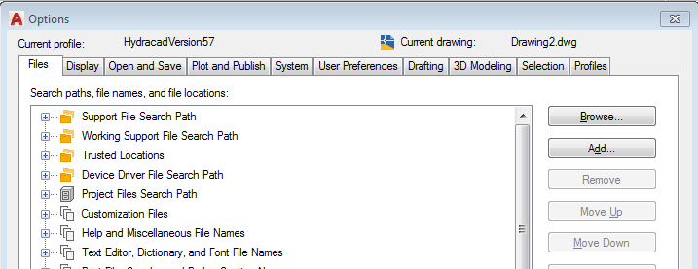

B. Pick on the ‘+’ (plus) next to Support File Search Path. Pick the Add button first then pick the Browse button next. Click through the folder structure until you come to the: HES/HydraCAD/Ver50/Programs/Version57 folder. Click on that folder and pick OK. See below.
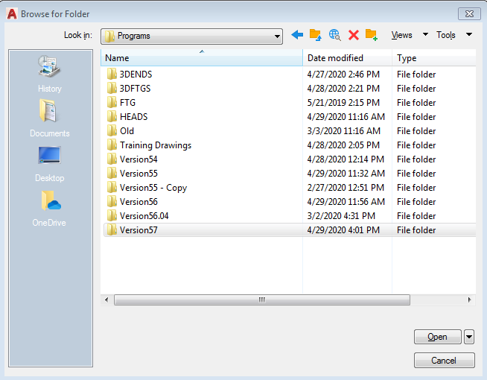

C. Pick the ‘+’ (plus) next to Template Settings, then the ‘+’ (plus) next to Drawing Template File Location. Click on the current entry that appears and pick Browse and click through the folders until you come to the same HES\HydraCAD\Ver50\Programs\Version57 folder. Click on that folder and pick OK. See below.

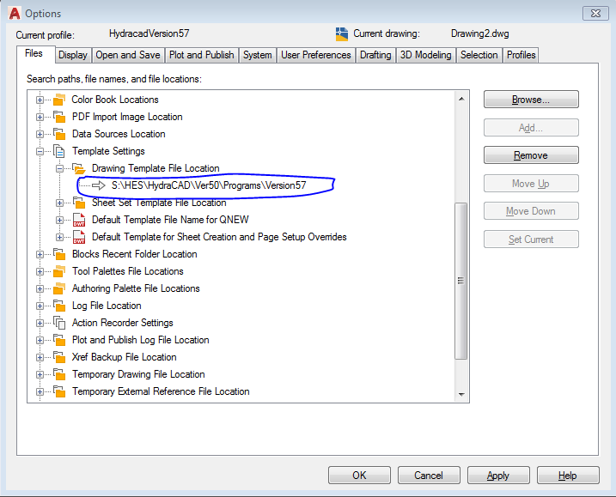

D. Pick the ‘+’ next to Trusted Locations, click on the current entry that appears and pick Browse. Click through the folders until you come to the HES\HydraCAD\Ver50\Programs\Version57 folder. Click on that folder and pick OK. See below. Pick the OK button when this has been completed.
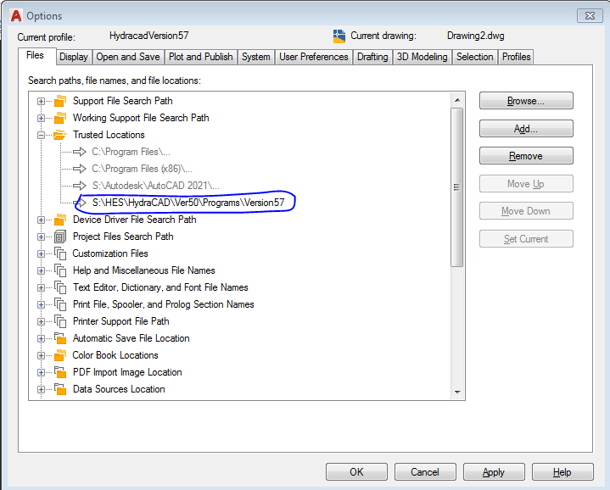

E. At the AutoCAD Command Prompt, type in MENU and press Enter. Click through the folders until you come to the HES\HydraCAD\Ver50\Programs\Version57 folder and pick HCADWIN.CUIX. See below.
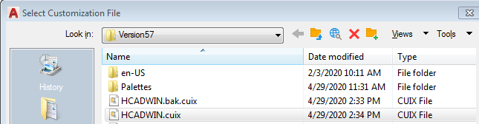
F. Exit AutoCAD and then re-enter AutoCAD

