Updating to the new preview version of the publisher, I was greeted with the following:
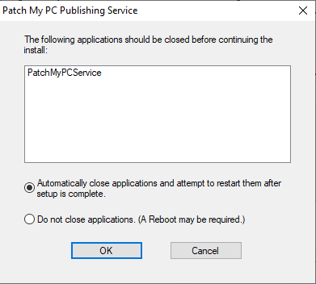
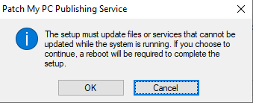
This can be avoided by setting the 0x2 bit to stop the service on install as well as uninstall:
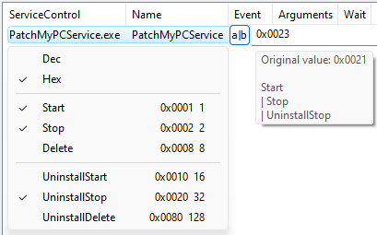
You would normally select UninstallDelete here as well, but there are custom actions to install and uninstall the service, and doing so removes the service before this custom action runs, causing the entire MSI uninstall to fail. This can be remedied by setting the 0x40 ‘ContinueOnReturn’ attribute of the custom action:
